Paper Title
First Author¹, Second Author²
¹Name of the first author's organization, ²Name of the second author's organization
First author e-mail: name.surname@example.org

Abstract. This document is a template and already defines the components of your paper [title, text, heads, etc.].For the papers written in Slovene language an English title and abstract is required. The abstract should be no more than 200 words.
We accept only electronic submissions in Microsoft Word or Adobe PDF format. Submission form can be found on SRK web page [1].

Introduction
Papers submitted to the Seminar on Optical Communications (SOK) should be prepared using this template (A4 format in two columns with all margins set to 2.25 cm). Papers should be four pages long, including references and short author biographies.

Writing Instructions
When writing, use the styles defined in this document and do not change the font size or style. This document may be used as a template for preparing your paper. Table 1 summarizes the basic styles and font sizes.
Each first paragraph should be written without indentation, while all following paragraphs should have the first line indented.
Table 1. Title of the table and a brief description of its contents.
Text Style | Font Size | Attributes
Paper title  Author names  Affiliation  Heading  Subheading  Regular text  Captions & ref. | 17pt  12pt  10pt  12pt  10pt  10pt  9pt | bold  bold  italic  bold  bold

Equations and Figures
Equations should be written in italic type and numbered consecutively. References to equations in the text should be given in parentheses (1).

$F_{0}=10 log⁡(F1 F2 F3 F4 F5 )$$\int_{ 0}^{ r_{2}}{ F(r,}$$F_0=10 log⁡(F_1 F_2 F_3 F_4 F_5 )$ (1)

Figures should be placed within one-column or two-column frames and labeled with a figure number and caption. References to figures must be included in the text (Figure 1). Ensure that figures are of sufficient quality for publication.
Automatic figure numbering (Insert Caption) and the use of bookmarks for references are recommended. Figure 1.

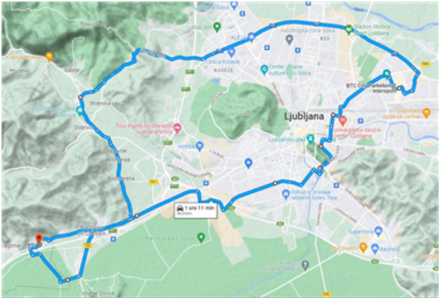
Figure 1. Insert the figure title and a brief explanation here.

Writing and Submission of Paper
Instructions for writing and submitting papers can be found on the website [1]. We accept papers in PDF or Microsoft Word format. Before submission, please check the information for authors available on the website [1].
Please observe the submission deadline. Send your paper to: bostjan.batagelj@fe.uni-lj.si.

Literature
[1] SOK, https:\\sok.fe.uni-lj.si
[2] A. S. Tanenbaum in H. Bos, Modern Operating Systems, 4th ed. Boston, MA: Pearson, 2015. (BOOK)
[3] J. Smith in R. Jones, “Vehicle trust modeling in dynamic networks,” IEEE Transactions on Vehicular Technology, vol. 68, no. 4, pp. 3251–3264, 2019. (ARTICLE)

About the Author
The author biography should be three to five sentences long and contain basic information such as education, profession, current position, major works, and similar details. An author photo is welcome but not mandatory if the author does not wish to provide one.
AUTHOR PHOTO (approx. 3 x 2.6 cm)

